Date: April 15, 2023

To,

HR Manager

XYZ Company

123 Main Street

Dhaka, Bangladesh

**Subject: Application for the Position of Backend Web Developer.**

Dear Hiring Manager,

I am writing to express my interest in the Backend Web Developer position advertised on your website. As a highly motivated and skilled developer with experience in Laravel, Vue.js, MERN stack, MongoDB, and Node.js, I am confident that I am the perfect candidate for this position. I completed my Bachelor's degree in Computer Science from Bangladesh Army University of Science & Technology (BAUST), Saidpur. During my time there, I gained valuable knowledge and hands-on experience in web development, including building scalable and maintainable backend systems using a variety of technologies.

In addition to my academic qualifications, I have also worked on several projects as a freelance developer, where I gained experience in building web applications using Laravel, Vue.js, and MERN stack. These experiences have equipped me with in-depth knowledge of the various technologies and frameworks used in web development. As a dedicated and detail-oriented developer, I believe in delivering high-quality code that meets the project's specifications and requirements. I also possess excellent problem-solving skills and am constantly seeking to learn new technologies and improve my abilities.

I have attached my resume and relevant documents for your review. I would appreciate the opportunity to further discuss my qualifications and how they align with the needs of your company. Thank you for your consideration.

Sincerely,

( Nahid Hasan Arif )

Enclosure: 1. Curriculum Vitae

Enclosure: 1. Curriculum Vitae

I am confident and enthusiastic enough to take the challenges that the job requires. Sharing knowledge as well as seeking new perspectives along with the opportunity of research are my area of interest. Hence, I want to pursue a long-term career with challenge and commitment in the profession of teaching in an ethical way.

NAFEES FOYSOL AKHER

Flat

-

2

A, House

-

448

, Road

-

, Block

17

-

G

Bashundhara R/A, Dhaka 1229

Cell No

–

01727702370

Email:

nafeesfoysolakher@gmail.com

CAREER

OBJECTIVE

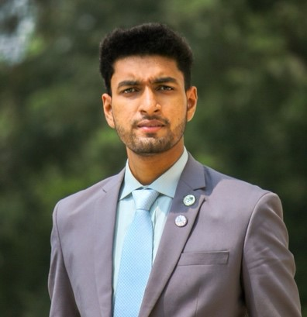

ACADEMIC CREDENTIALS

* **Master of Arts** inEnglish Literature and Cultural Studies

CGPA: 3.82 (3rd Position), Year of Passing: 2021

Bangladesh University of Professionals

* **Bachelor of Arts (Honors)** in English

CGPA: 3.70 (4th Position), Year of Passing: 2020

Bangladesh University of Professionals

* **Higher Secondary Certificate**

GPA: 5.00 (Science), Year of Passing: 2016

Dhaka Residential Model College

* **Secondary School Certificate**

GPA: 5.00 (Science), Year of Passing: 2014

Monipur High School and College

Mother Tongue: Four Skills (Reading, Writing, Listening, Speaking)

LANGUAGE PROFICIENCY

English: Four Skills (Reading, Writing, Listening, Speaking)

COMPUTER LITERACY

Operating System: Windows and MacOS

Skill: MS Word, MS Excel, MS Power Point

PERSONAL STRENGTH

Confidence, Integrity,

Patience

,

Leadership

,

Adaptability

, Punctuality,

Diligence

PERSONAL DETAILS

Name:

Nafees Foysol Akher

|  |  |  |
| --- | --- | --- |
| Father’s Name: Md. Abdul Akher |  | Mother’s Name: Arjia Begum |
| Date of Birth: 24th January 1999 |  | Gender: Male |
| Nationality: Bangladeshi (By Birth) |  | Marital Status: Unmarried |
|  |  |  |
| Blood Group: A(+) |  |  |

REFERENCES

|  |  |  |  |
| --- | --- | --- | --- |
| **1) Muhammad Nurul Islam** |  |  | **2) Dr. Fahmida Haque** |
| Assistant Professor |  |  | Associate Professor |
| Department of English |  |  | Department of English |

Bangladesh University of Professionals Bangladesh University of Professionals

Phone: +880176 Phone: +880176

Email: islamnurul6376@gmail.com Email: fahmida.haque@bup.edu.bd DECLARATION

I declare myself that the information provided is correct and can be treated as part of my subsequent contact of employment.

Name:

Nafees Foysol Akher

Date: 27th September 2022